Ideation Phase
Brainstorm & Idea Prioritization Template

Date | 08 Febrauary 2026
Team ID | LTVIP2026TMIDS66040
Project Name | IntelliSQL: Intelligent SQL Querying with LLMs Using Gemini Pro
Maximum Marks | 4 Marks

Step-1: Team Gathering, Collaboration and Select the Problem Statement
The team gathered to discuss real-world problems related to database management and SQL querying. After collaborative discussion, we identified that many users struggle to write SQL queries due to lack of technical knowledge, complex database schemas, and syntax errors. Based on this analysis, we selected the problem of converting natural language queries into SQL queries. This led to the idea of developing IntelliSQL: Intelligent SQL Querying with LLMs Using Gemini Pro.
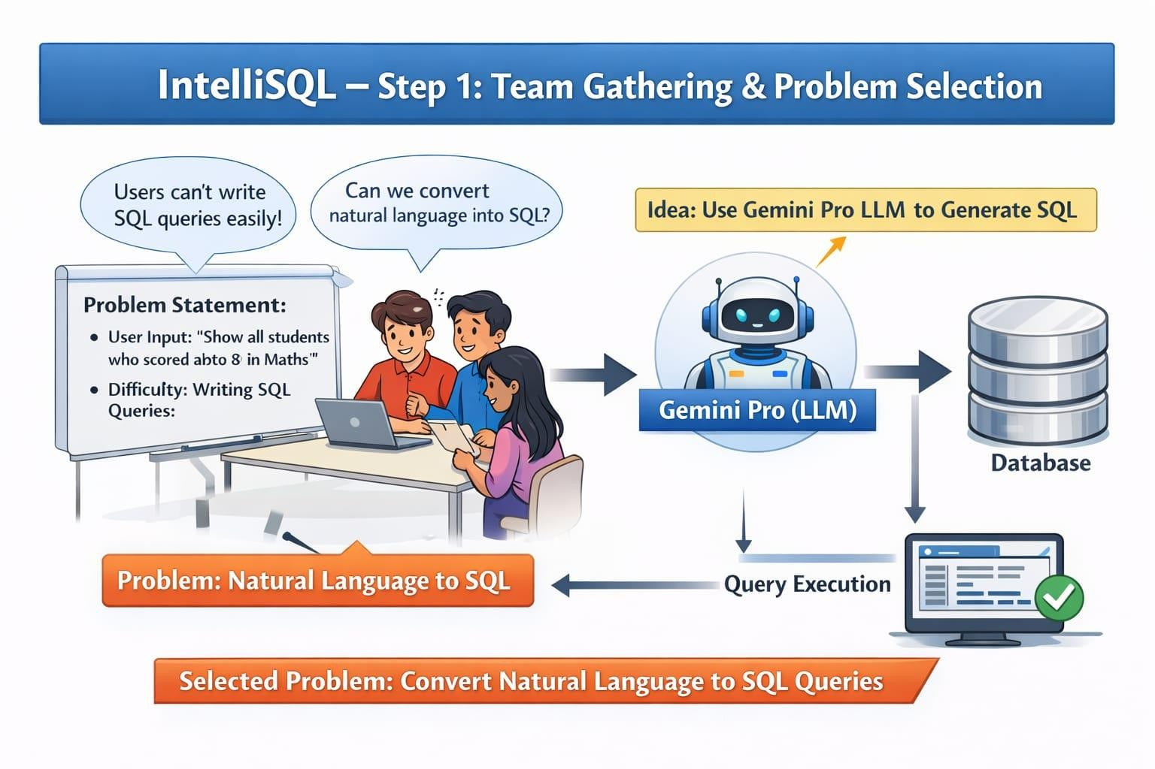

Step-2: Brainstorm, Idea Listing and Grouping
During brainstorming, the team generated multiple ideas:
- Natural Language to SQL conversion
- Schema-aware query generation
- Integration with Gemini Pro LLM
- Query validation and error correction
- User-friendly web interface
- Query explanation in simple English
- Query history tracking

These ideas were grouped into core AI features, user interface features, and advanced support features.

Step-3: Idea Prioritization
After evaluating feasibility and impact, the team prioritized the ideas as follows: High Priority:
- Natural Language to SQL conversion
- Gemini Pro integration
- Schema-aware SQL generation

Medium Priority:
- Query explanation module
- Query validation and optimization

Low Priority (Future Scope):
- Multi-database support
- Advanced analytics dashboard
